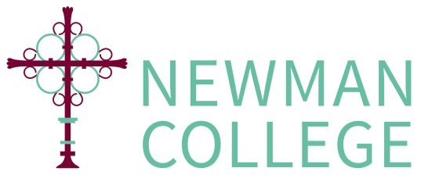

Bursary 2024-2025
CONFIDENTIAL

PLEASE ALSO ENSURE YOU HAVE APPLIED FOR FREE SCHOOL MEALS FROM BRIGHTON AND HOVE COUNCIL
https://www.brighton-hove.gov.uk/schools-and-learning/free-school-meal

Bank Details

Student Name: ________________________________ Form: _______

Student College Email Address: _________________________________

Name of Bank: __________________________________________________

Address of Bank: __________________________________________________

__________________________________________________

__________________________________________________

Name on account: __________________________________________________

Sort Code: |  |  | - |  |  | -

Bank Account Number:

To be completed and submitted with your first discretionary bursary application

Please return the completed application form (including relevant evidence to support the claim) to Mr Marsh or Ms S Highland, Sixth Form Administrator, Newman College Reception.

